Realization of the Function using ANN…

# Output Result:-

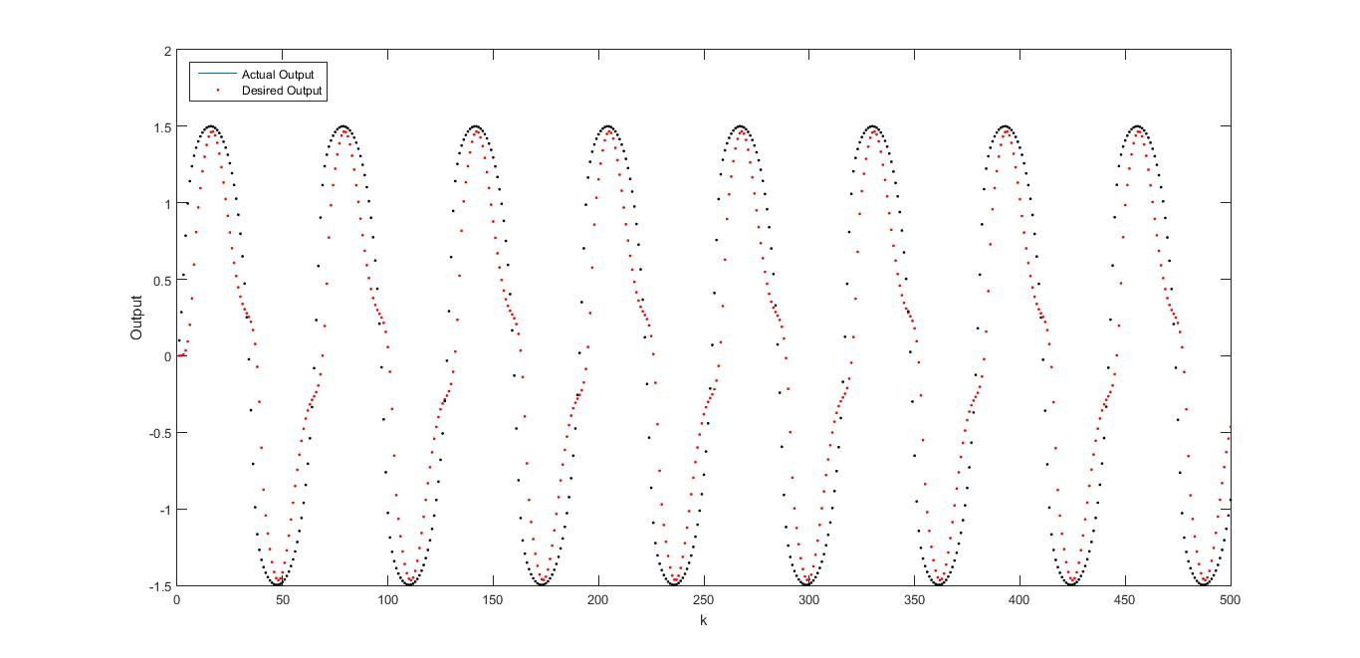

# Average Error during Training

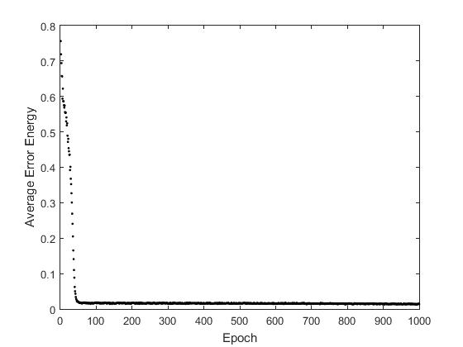

# Training Set

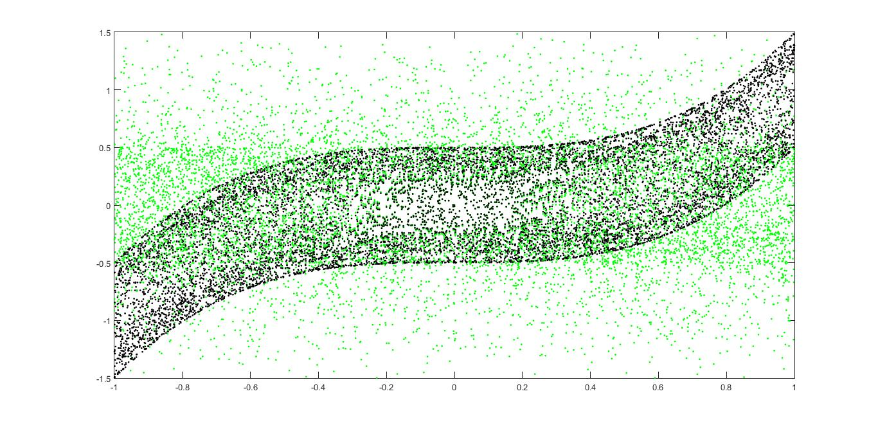

# Steps:-

1. 10,000 training Examples were generated randomly using the equation (fig 3).
2. A Multilayer Neural Network was designed as 2-15-1 .
3. For Hidden Layer and Output Layer, a bias unit was added in the inputs.
4. Weights of all Neuron were initialized randomly.
5. Hyperbolic Tan was used as Sigmoid Function.
6. Gradient Decent was used to minimize the Error Function.
7. Learning Rate was taken as 0.01.
8. ANN was trained for 1,000 Epochs. For each epoch, randomly 1,000 training examples were chosen from the set of 10,000 examples.
9. Average Error Energy was plotted against Epochs (Fig 2).

## For Evaluating the ANN,

500 discreet points were given to the network as Sin(0.1*k). Second input was taken as Output of previous input.

Actual Output and Desired output was plotted as in fig 1.